Experiment-12

Aim
To perform a 270-degree clockwise rotation of an image using Python and OpenCV.

Procedure
- Import the OpenCV library.
- Read the input image using cv2.imread().
- Rotate the image by 270 degrees clockwise using cv2.rotate().
- Display the original and rotated images.
- Close the windows after a key is pressed.

Code
import cv2
img = cv2.imread("image.jpg")
rotated = cv2.rotate(img, cv2.ROTATE_90_COUNTERCLOCKWISE)
cv2.imshow("Original Image", img)cv2.imshow("Rotated Image", rotated)
cv2.waitKey(0)cv2.destroyAllWindows()

Sample Input
An image named image.jpg.

Sample Output
- Original image displayed in the first window.

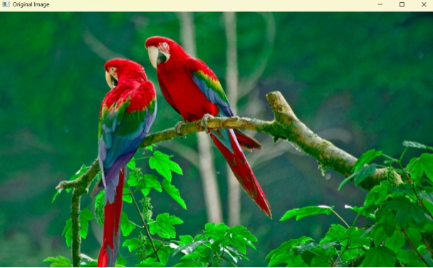
- Image rotated by 270 degrees clockwise displayed in the second window.
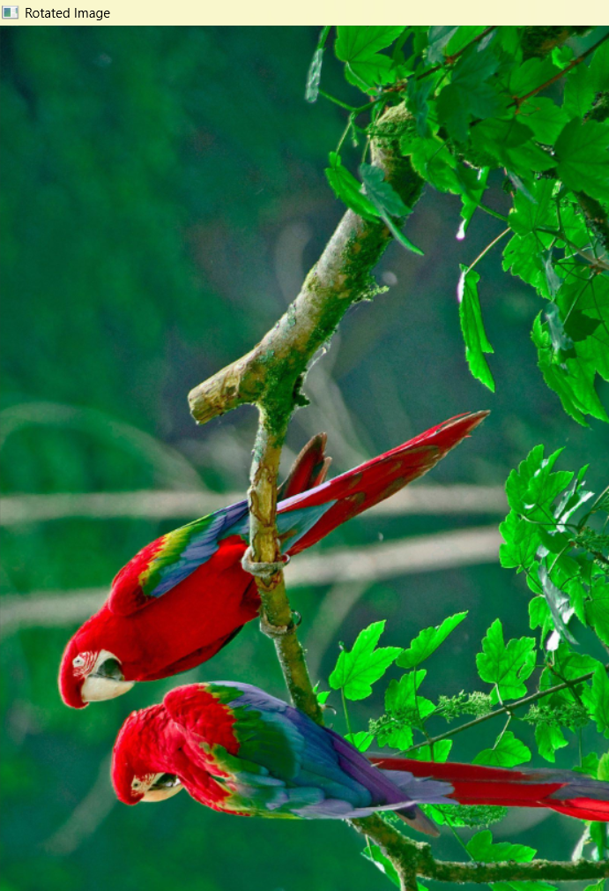

Result
Thus, the input image was successfully rotated by 270 degrees clockwise using Python and OpenCV.

